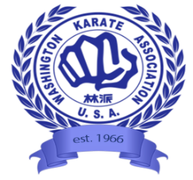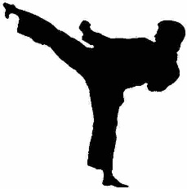
WASHINGTON KARATE
ASSOCIATION
SUMMER CAMPS 2022

SUMMER KARATE CAMPS

This Photo by Unknown Author is licensed under CC BY-ND

Sign up for an exciting week or weeks of Summer Camp at the Washington Karate Association! Activities include lessons in Japanese language lessons, academic activities, games, team building activities, arts and crafts, all in a respectful dojo environment. Karate instruction is for all levels- beginner to advanced. Camp will be supervised and led by dojo Senseis and Sempais.

Session 1: July 18th- 22nd (Monday-Friday 9am-5pm)
Session 2: July 25th – 29th (Monday-Friday 9am-5pm)
Session 3 : August 22nd -26th (Monday-Friday 9am-5pm)

Cost- $375/Session (WKA members), $425/Session (non members)
$1000/all 3 weeks (WKA members), $1147.50/all 3 weeks (non members)

WKA members refers to those on the standard one year program or 5 year program. Second & third family members are discounted 30% and 50%, 5 year program members 10% off.
Spaces are limited. Registrations require a $50 deposit and will close 2 weeks prior to each camp. Late registration fee is $20 and are only accepted if space is available. Deposits are non-refundable unless the camp is cancelled.

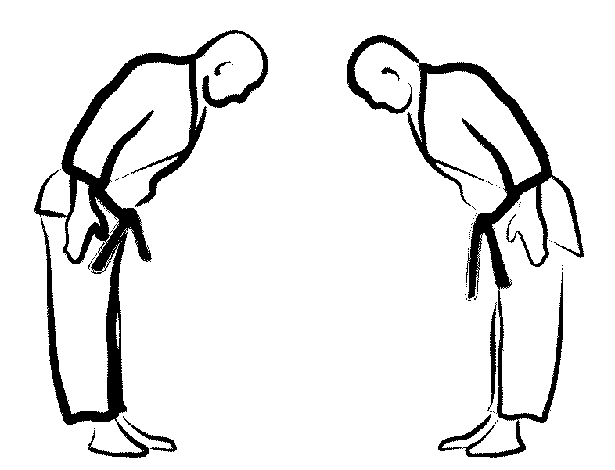

For more information, call WKA Bellevue Dojo (425)641-8123 or email sensei@wkabellevue.com

